​Jesus said, “Let the little children come to me, and do not hinder them, for the kingdom of heaven belongs to such as these.”​ Matthew 19:14​
​

Child Protection Training
Philippines
July 2026

together with 


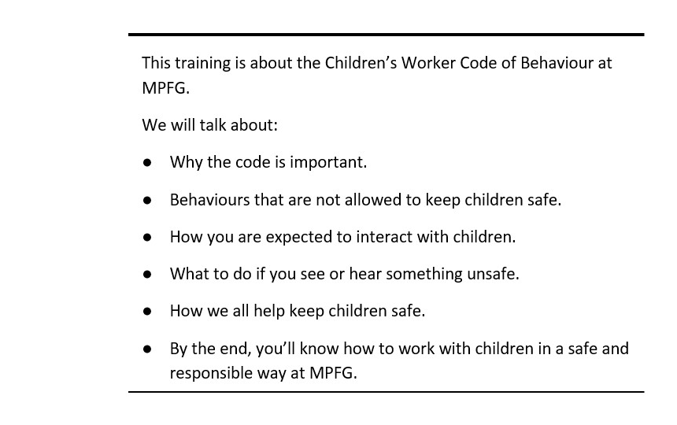

NOTES :
_______________________________________________________________________________________
_______________________________________________________________________________________
_______________________________________________________________________________________
_______________________________________________________________________________________
_______________________________________________________________________________________
_______________________________________________________________________________________
_______________________________________________________________________________________
_______________________________________________________________________________________
_______________________________________________________________________________________
_______________________________________________________________________________________
_______________________________________________________________________________________
_______________________________________________________________________________________
_______________________________________________________________________________________
_______________________________________________________________________________________
_______________________________________________________________________________________
_______________________________________________________________________________________
_______________________________________________________________________________________
_______________________________________________________________________________________
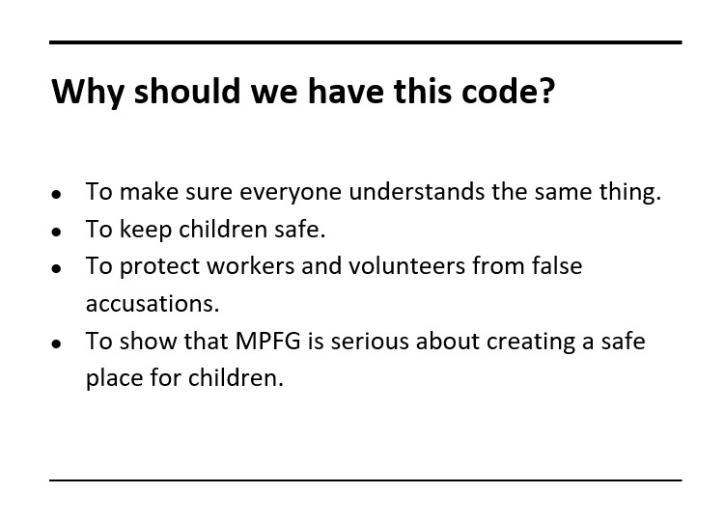
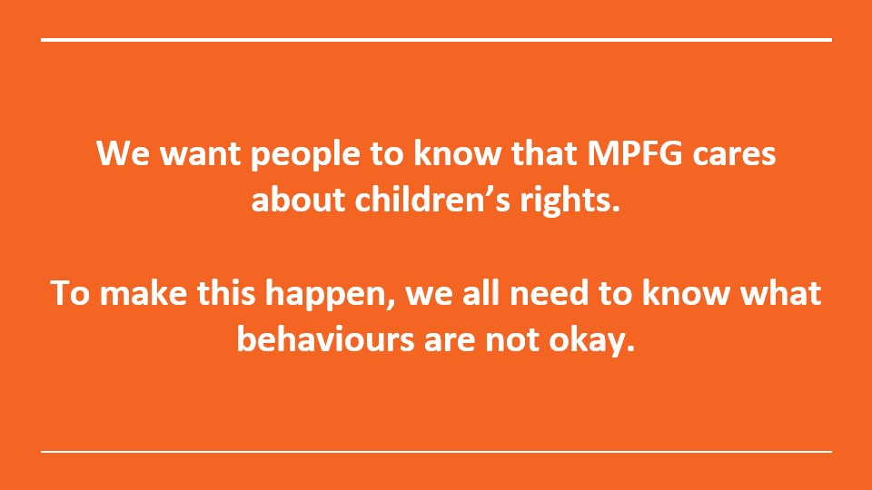
Group Discussion: How do we keep children safe when they attend our programs? What do we need to look out for and be aware of?
NOTES :
_______________________________________________________________________________________
_______________________________________________________________________________________
_______________________________________________________________________________________
_______________________________________________________________________________________
_______________________________________________________________________________________
_______________________________________________________________________________________
_______________________________________________________________________________________
_______________________________________________________________________________________
_______________________________________________________________________________________
_______________________________________________________________________________________
_______________________________________________________________________________________
_______________________________________________________________________________________
_______________________________________________________________________________________
_______________________________________________________________________________________
_______________________________________________________________________________________
_______________________________________________________________________________________
_______________________________________________________________________________________
_______________________________________________________________________________________
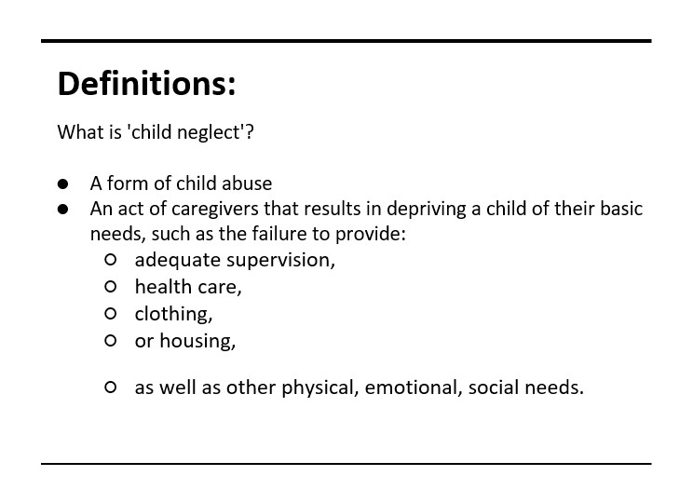
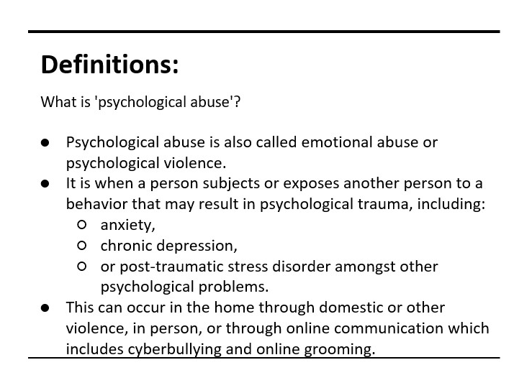

NOTES :
_______________________________________________________________________________________
_______________________________________________________________________________________
_______________________________________________________________________________________
_______________________________________________________________________________________
_______________________________________________________________________________________
_______________________________________________________________________________________
_______________________________________________________________________________________
_______________________________________________________________________________________
_______________________________________________________________________________________
_______________________________________________________________________________________
_______________________________________________________________________________________
_______________________________________________________________________________________
_______________________________________________________________________________________
_______________________________________________________________________________________
_______________________________________________________________________________________
_______________________________________________________________________________________
_______________________________________________________________________________________
_______________________________________________________________________________________
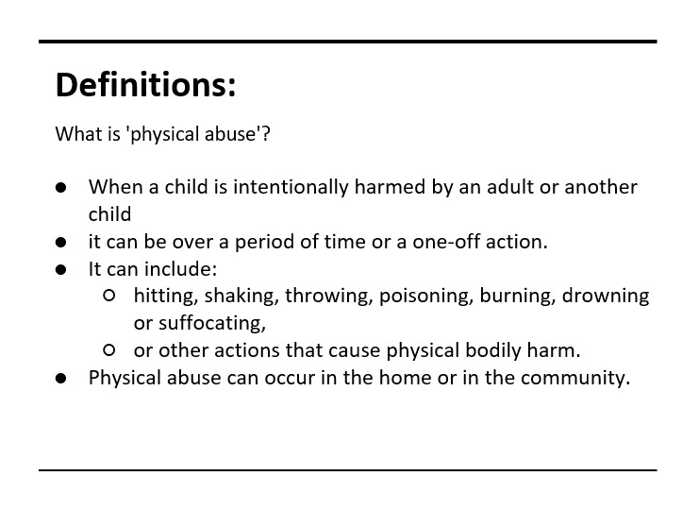
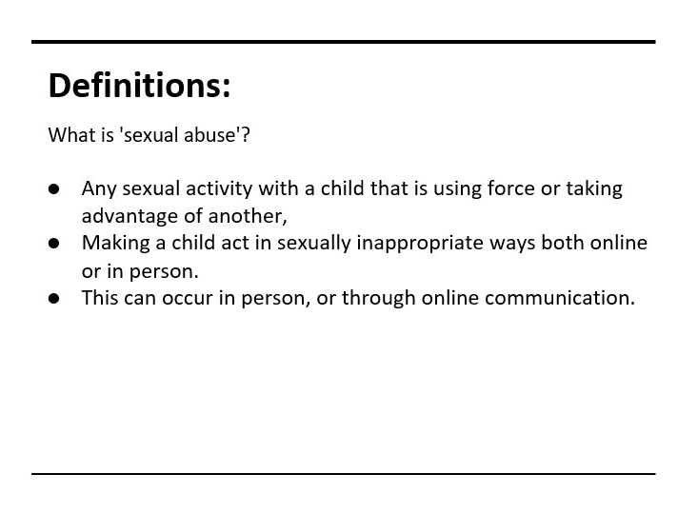
NOTES :
_______________________________________________________________________________________
_______________________________________________________________________________________
_______________________________________________________________________________________
_______________________________________________________________________________________
_______________________________________________________________________________________
_______________________________________________________________________________________
_______________________________________________________________________________________
_______________________________________________________________________________________
_______________________________________________________________________________________
_______________________________________________________________________________________
_______________________________________________________________________________________
_______________________________________________________________________________________
_______________________________________________________________________________________
_______________________________________________________________________________________
_______________________________________________________________________________________
_______________________________________________________________________________________
_______________________________________________________________________________________
_______________________________________________________________________________________

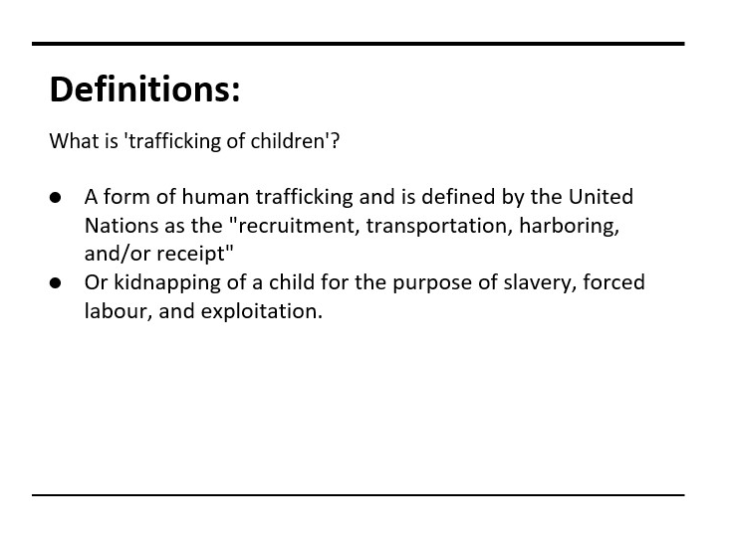
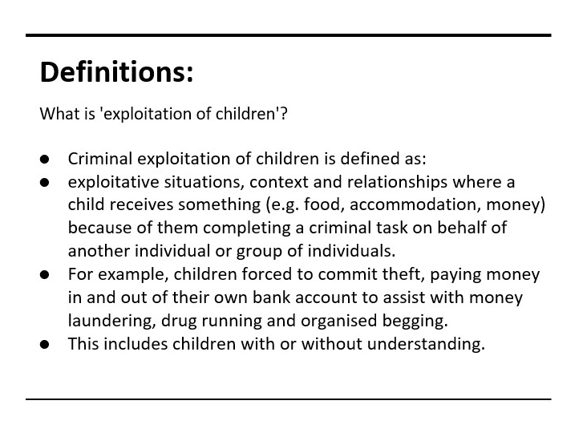
NOTES :
_______________________________________________________________________________________
_______________________________________________________________________________________
_______________________________________________________________________________________
_______________________________________________________________________________________
_______________________________________________________________________________________
_______________________________________________________________________________________
_______________________________________________________________________________________
_______________________________________________________________________________________
_______________________________________________________________________________________
_______________________________________________________________________________________
_______________________________________________________________________________________
_______________________________________________________________________________________
_______________________________________________________________________________________
_______________________________________________________________________________________
_______________________________________________________________________________________
_______________________________________________________________________________________
_______________________________________________________________________________________
_______________________________________________________________________________________
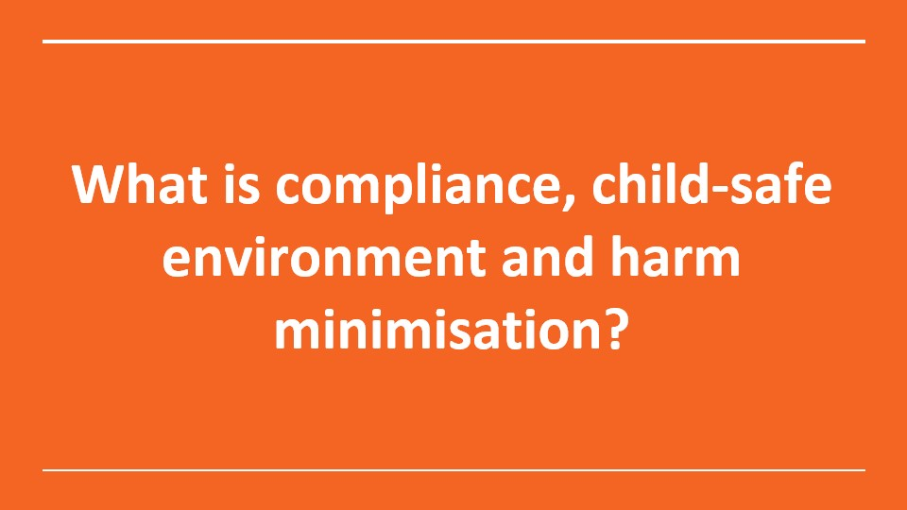
Group Discussion: What is currently done, to protect the children you work with?
NOTES :
_______________________________________________________________________________________
_______________________________________________________________________________________
_______________________________________________________________________________________
_______________________________________________________________________________________
_______________________________________________________________________________________
_______________________________________________________________________________________
_______________________________________________________________________________________
_______________________________________________________________________________________
_______________________________________________________________________________________
_______________________________________________________________________________________
_______________________________________________________________________________________
_______________________________________________________________________________________
_______________________________________________________________________________________
_______________________________________________________________________________________
_______________________________________________________________________________________
_______________________________________________________________________________________
_______________________________________________________________________________________
_______________________________________________________________________________________
_______________________________________________________________________________________
_______________________________________________________________________________________
_______________________________________________________________________________________
_______________________________________________________________________________________
_______________________________________________________________________________________
_______________________________________________________________________________________
_______________________________________________________________________________________
_______________________________________________________________________________________
_______________________________________________________________________________________
_______________________________________________________________________________________
_______________________________________________________________________________________
_______________________________________________________________________________________
_______________________________________________________________________________________
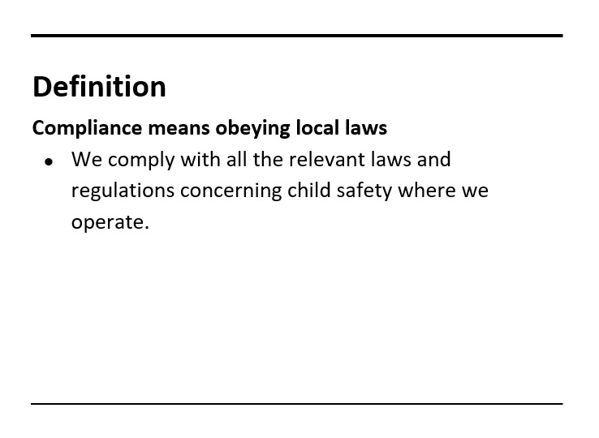
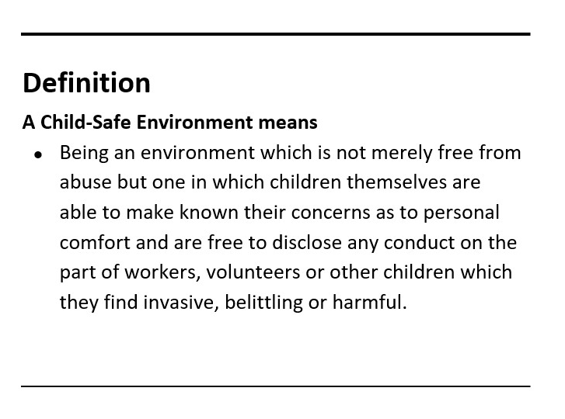
NOTES :
_______________________________________________________________________________________
_______________________________________________________________________________________
_______________________________________________________________________________________
_______________________________________________________________________________________
_______________________________________________________________________________________
_______________________________________________________________________________________
_______________________________________________________________________________________
_______________________________________________________________________________________
_______________________________________________________________________________________
_______________________________________________________________________________________
_______________________________________________________________________________________
_______________________________________________________________________________________
_______________________________________________________________________________________
_______________________________________________________________________________________
_______________________________________________________________________________________
_______________________________________________________________________________________
_______________________________________________________________________________________
_______________________________________________________________________________________
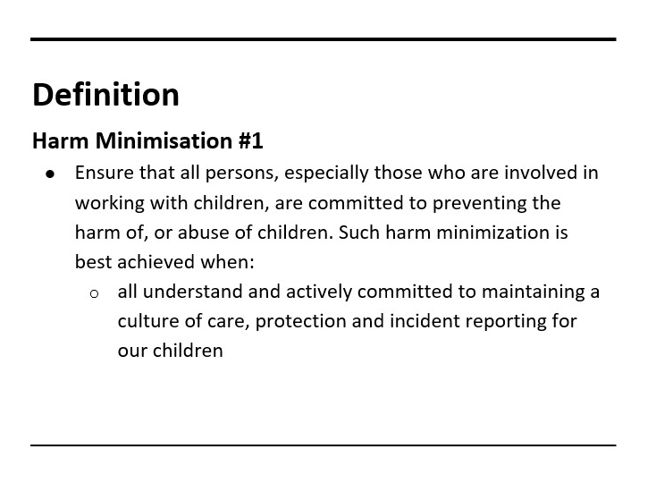
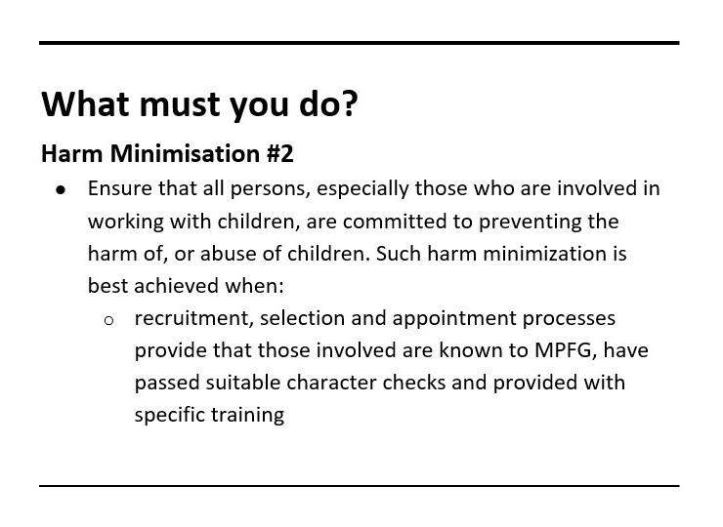
NOTES :
_______________________________________________________________________________________
_______________________________________________________________________________________
_______________________________________________________________________________________
_______________________________________________________________________________________
_______________________________________________________________________________________
_______________________________________________________________________________________
_______________________________________________________________________________________
_______________________________________________________________________________________
_______________________________________________________________________________________
_______________________________________________________________________________________
_______________________________________________________________________________________
_______________________________________________________________________________________
_______________________________________________________________________________________
_______________________________________________________________________________________
_______________________________________________________________________________________
_______________________________________________________________________________________
_______________________________________________________________________________________
_______________________________________________________________________________________
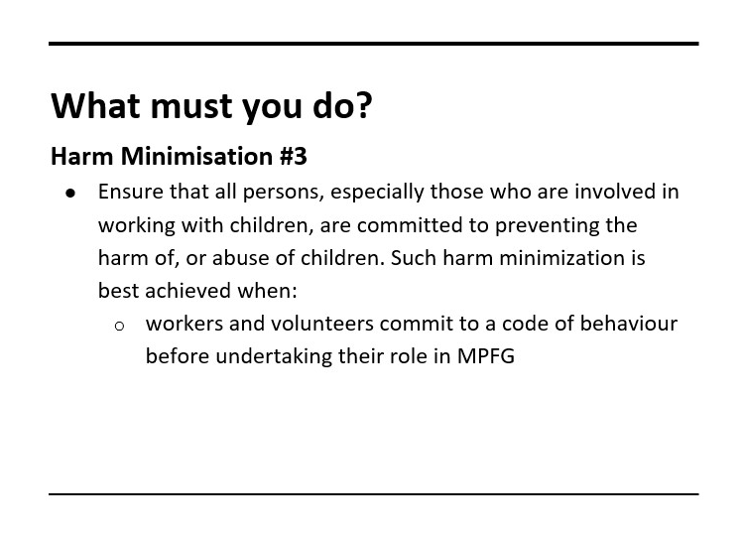
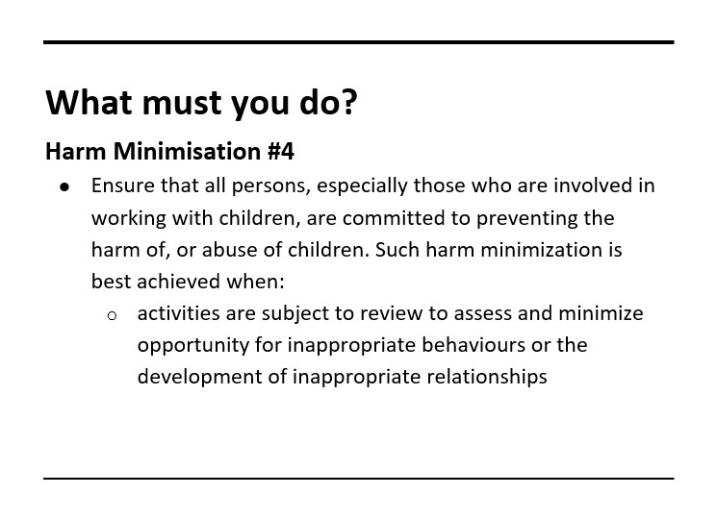

NOTES :
_______________________________________________________________________________________
_______________________________________________________________________________________
_______________________________________________________________________________________
_______________________________________________________________________________________
_______________________________________________________________________________________
_______________________________________________________________________________________
_______________________________________________________________________________________
_______________________________________________________________________________________
_______________________________________________________________________________________
_______________________________________________________________________________________
_______________________________________________________________________________________
_______________________________________________________________________________________
_______________________________________________________________________________________
_______________________________________________________________________________________
_______________________________________________________________________________________
_______________________________________________________________________________________
_______________________________________________________________________________________
_______________________________________________________________________________________

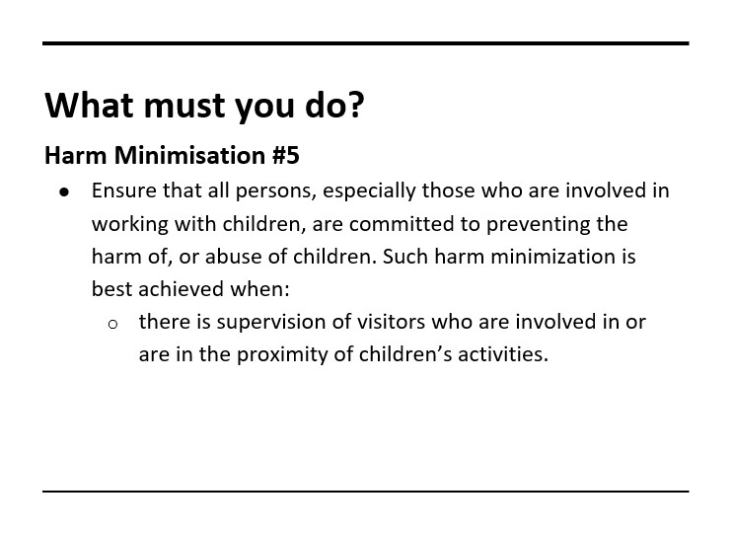
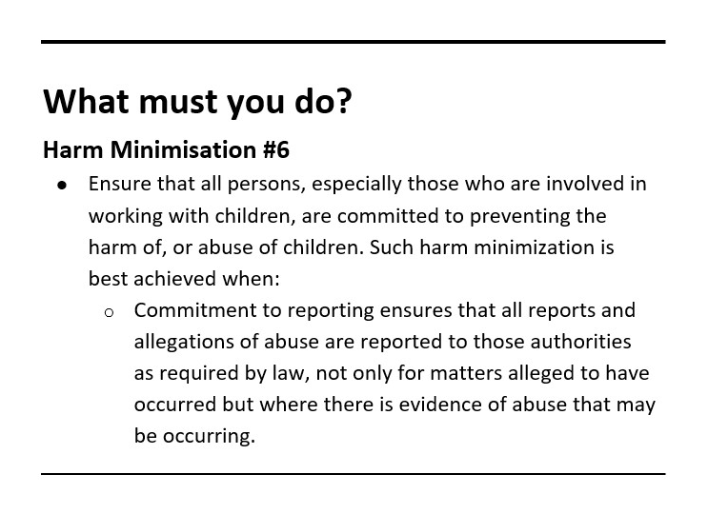

NOTES :
_______________________________________________________________________________________
_______________________________________________________________________________________
_______________________________________________________________________________________
_______________________________________________________________________________________
_______________________________________________________________________________________
_______________________________________________________________________________________
_______________________________________________________________________________________
_______________________________________________________________________________________
_______________________________________________________________________________________
_______________________________________________________________________________________
_______________________________________________________________________________________
_______________________________________________________________________________________
_______________________________________________________________________________________
_______________________________________________________________________________________
_______________________________________________________________________________________
_______________________________________________________________________________________
_______________________________________________________________________________________
_______________________________________________________________________________________


Group discussion: ​ How do we create an environment so that children feel believed and safe so they can report abuse?
NOTES :
_______________________________________________________________________________________
_______________________________________________________________________________________
_______________________________________________________________________________________
_______________________________________________________________________________________
_______________________________________________________________________________________
_______________________________________________________________________________________
_______________________________________________________________________________________
_______________________________________________________________________________________
_______________________________________________________________________________________
_______________________________________________________________________________________
_______________________________________________________________________________________
_______________________________________________________________________________________
_______________________________________________________________________________________
_______________________________________________________________________________________
_______________________________________________________________________________________
_______________________________________________________________________________________
_______________________________________________________________________________________
_______________________________________________________________________________________
_______________________________________________________________________________________
_______________________________________________________________________________________
_______________________________________________________________________________________
_______________________________________________________________________________________
_______________________________________________________________________________________
_______________________________________________________________________________________
_______________________________________________________________________________________

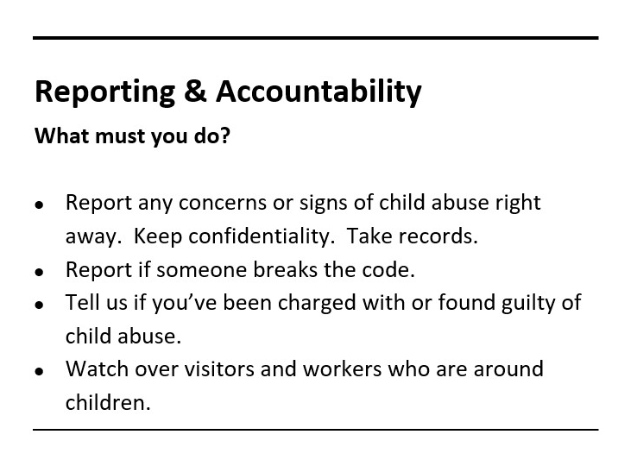
As a child protection officer – you report directly to Primrose.​
If you receive a report from one of your workers or volunteers – what do you do?
(We will look at this in more depth in our second training)

NOTES :
_______________________________________________________________________________________
_______________________________________________________________________________________
_______________________________________________________________________________________
_______________________________________________________________________________________
_______________________________________________________________________________________
_______________________________________________________________________________________
_______________________________________________________________________________________
_______________________________________________________________________________________
_______________________________________________________________________________________
_______________________________________________________________________________________
_______________________________________________________________________________________
_______________________________________________________________________________________
_______________________________________________________________________________________
_______________________________________________________________________________________
_______________________________________________________________________________________
_______________________________________________________________________________________
_______________________________________________________________________________________
_______________________________________________________________________________________

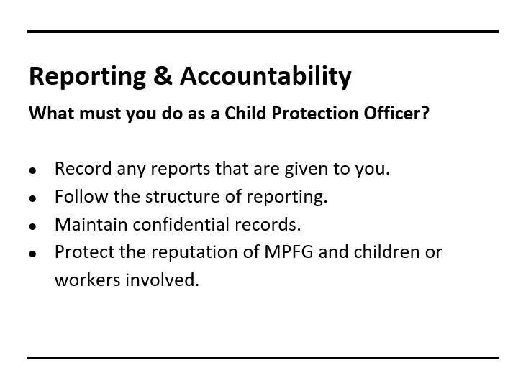

NOTES :
_______________________________________________________________________________________
_______________________________________________________________________________________
_______________________________________________________________________________________
_______________________________________________________________________________________
_______________________________________________________________________________________
_______________________________________________________________________________________
_______________________________________________________________________________________
_______________________________________________________________________________________
_______________________________________________________________________________________
_______________________________________________________________________________________
_______________________________________________________________________________________
_______________________________________________________________________________________
_______________________________________________________________________________________
_______________________________________________________________________________________
_______________________________________________________________________________________
_______________________________________________________________________________________
_______________________________________________________________________________________
_______________________________________________________________________________________

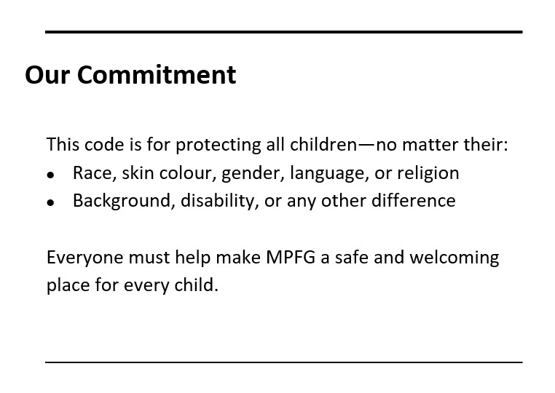
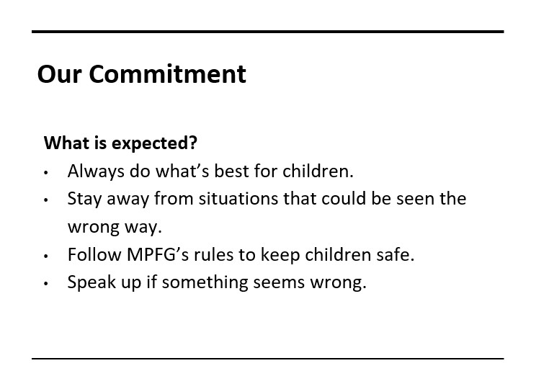

NOTES :
_______________________________________________________________________________________
_______________________________________________________________________________________
_______________________________________________________________________________________
_______________________________________________________________________________________
_______________________________________________________________________________________
_______________________________________________________________________________________
_______________________________________________________________________________________
_______________________________________________________________________________________
_______________________________________________________________________________________
_______________________________________________________________________________________
_______________________________________________________________________________________
_______________________________________________________________________________________
_______________________________________________________________________________________
_______________________________________________________________________________________
_______________________________________________________________________________________
_______________________________________________________________________________________
_______________________________________________________________________________________
_______________________________________________________________________________________

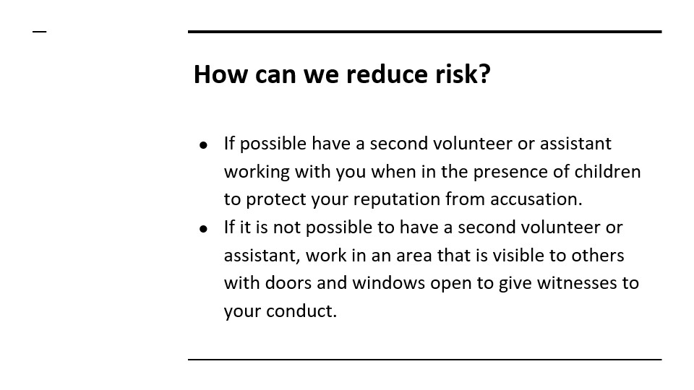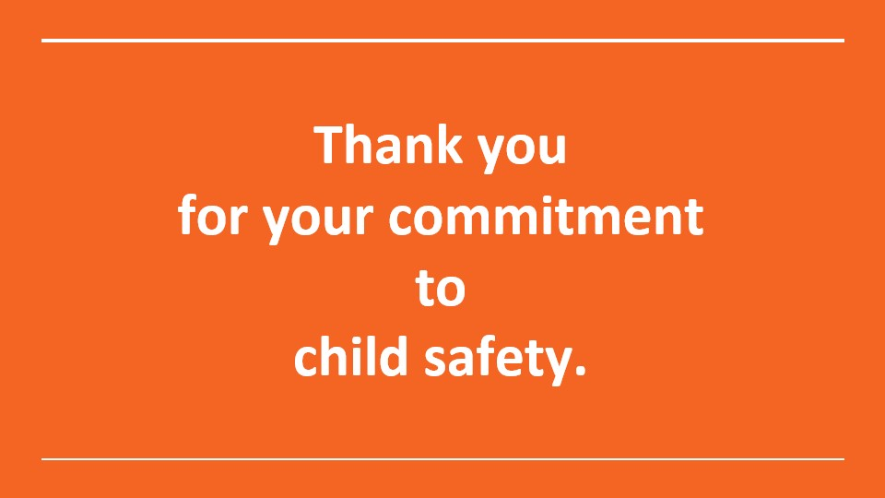

NOTES :
_______________________________________________________________________________________
_______________________________________________________________________________________
_______________________________________________________________________________________
_______________________________________________________________________________________
_______________________________________________________________________________________
_______________________________________________________________________________________
_______________________________________________________________________________________
_______________________________________________________________________________________
_______________________________________________________________________________________
_______________________________________________________________________________________
_______________________________________________________________________________________
_______________________________________________________________________________________
_______________________________________________________________________________________
_______________________________________________________________________________________
_______________________________________________________________________________________
_______________________________________________________________________________________
_______________________________________________________________________________________
_______________________________________________________________________________________

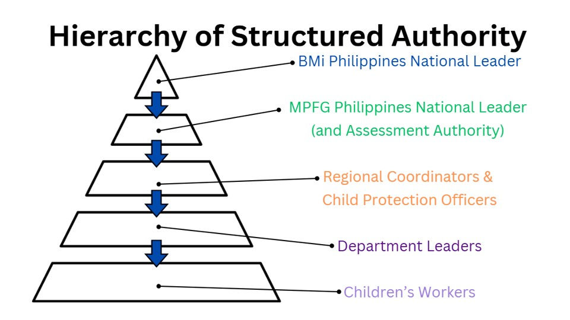
Let’s take a closer look at the hierarchy of authority:
BMI Philippines National Leader: Pastor Primrose Chavez
MPFG Philippines National Leader: Pastor Primrose Chavez
MPFG Philippines Assessment Authority: Pastor Primrose Chavez, Menchie Ejosa, Phoebe Hope Chavez
Regional Coordinators & Child Protection Officers: Local church pastors and leaders who have been accredited as CPOs by MPFG Australia.
Department Leaders: Those appointed by local church pastors and MPFG program leaders to manage programs involving children
Children’s Workers: Volunteers who support the programs by providing assistance, support and supervision. These could be members of the church, parents or older siblings, people from external organisations employed to run programs with children.

NOTES :
_______________________________________________________________________________________
_______________________________________________________________________________________
_______________________________________________________________________________________
_______________________________________________________________________________________
_______________________________________________________________________________________
_______________________________________________________________________________________
_______________________________________________________________________________________
_______________________________________________________________________________________
_______________________________________________________________________________________
_______________________________________________________________________________________
_______________________________________________________________________________________
_______________________________________________________________________________________
_______________________________________________________________________________________
_______________________________________________________________________________________
_______________________________________________________________________________________
_______________________________________________________________________________________
_______________________________________________________________________________________
_______________________________________________________________________________________

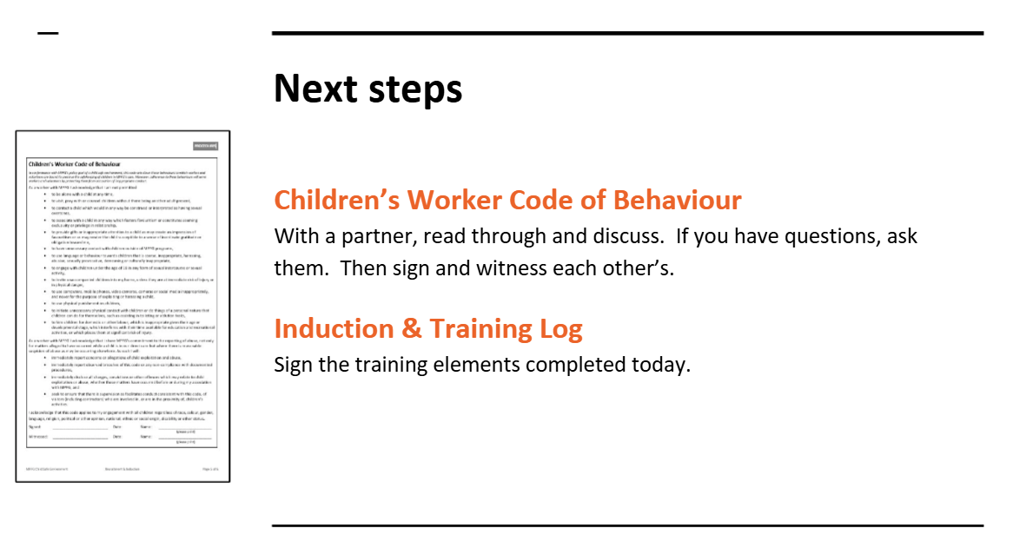

NOTES :
_______________________________________________________________________________________
_______________________________________________________________________________________
_______________________________________________________________________________________
_______________________________________________________________________________________
_______________________________________________________________________________________
_______________________________________________________________________________________
_______________________________________________________________________________________
_______________________________________________________________________________________
_______________________________________________________________________________________
_______________________________________________________________________________________
_______________________________________________________________________________________
_______________________________________________________________________________________
_______________________________________________________________________________________
_______________________________________________________________________________________
_______________________________________________________________________________________
_______________________________________________________________________________________
_______________________________________________________________________________________
_______________________________________________________________________________________

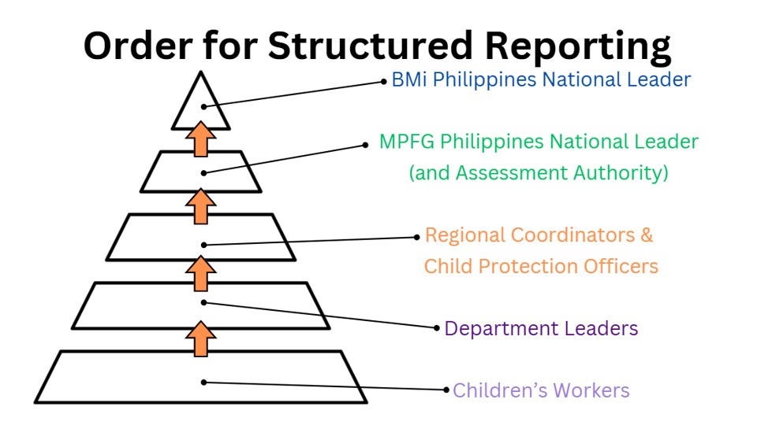

Let’s take a closer look at the appropriate structure for reporting:
Children’s Workers: Should only speak only to the Department Leader.
Department Leaders: Should only report only to regional coordinator/child protection officer.
Regional Coordinators & Child Protection Officers [CPO]: As a local church pastor or leader, you must report to the Assessment Authority or MPFG Philippines National Leader.

As the Regional Coordinator/CPO:
- it is YOUR decision whether you need to contact the Department of Social Welfare or your Local Barangay Council for the Protection of Children.
- Should you report to authorities, you must advise the Assessment Authority and keep them updates as you become aware of progress or action.
- You must maintain confidentiality to protect those involved and to protect the reputation of your local church, MPFG Philippines and Australia, as well as Bethesda Ministries International, Philippines.
- It is your responsibility to provide counselling to your volunteer children’s workers and department leaders in the event of them reporting to you, to ensure their wellbeing and closure of the matter.

NOTES :
_______________________________________________________________________________________
_______________________________________________________________________________________
_______________________________________________________________________________________
_______________________________________________________________________________________
_______________________________________________________________________________________
_______________________________________________________________________________________
_______________________________________________________________________________________
_______________________________________________________________________________________
_______________________________________________________________________________________
_______________________________________________________________________________________
_______________________________________________________________________________________
_______________________________________________________________________________________
_______________________________________________________________________________________
_______________________________________________________________________________________
_______________________________________________________________________________________
_______________________________________________________________________________________
_______________________________________________________________________________________
_______________________________________________________________________________________

In Summary: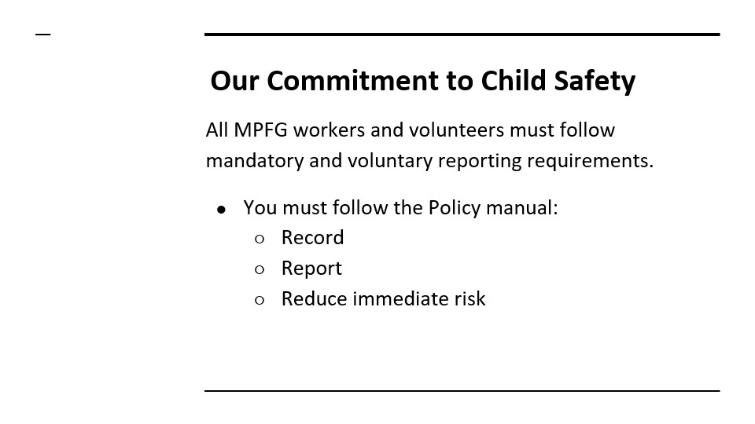


Children’s Worker Code of Behaviour
In conformance with MPFG’s policy goal of a child safe environment, this code sets down those behaviours to which workers and volunteers are bound to preserve the safekeeping of children in MPFG’s care. Moreover, adherence to these behaviours will serve workers and volunteers by protecting them from accusation of inappropriate conduct.
As a worker with MPFG I acknowledge that I am not permitted
- to be alone with a child at any time,
- to visit, pray with or counsel children without there being another adult present,
- to contact a child which would in any way be construed or interpreted as having sexual overtones,
- to associate with a child in any way which fosters favouritism or constitutes seeming exclusivity or privilege in relationship,
- to provide gifts or inappropriate attention to a child as may create an impression of favouritism or as may render the child susceptible to a sense of inordinate gratitude or obligation toward me,
- to have unnecessary contact with children outside of MPFG programs,
- to use language or behaviour towards children that is coarse, inappropriate, harassing, abusive, sexually provocative, demeaning or culturally inappropriate,
- to engage with children under the age of 18 in any form of sexual intercourse or sexual activity,
- to invite unaccompanied children into my home, unless they are at immediate risk of injury or in physical danger,
- to use computers, mobile phones, video cameras, cameras or social media inappropriately, and never for the purpose of exploiting or harassing a child,
- to use physical punishment on children,
- to initiate unnecessary physical contact with children or do things of a personal nature that children can do for themselves, such as assisting in toileting or ablution tasks,
- to hire children for domestic or other labour, which is inappropriate given their age or developmental stage, which interferes with their time available for education and recreational activities, or which places them at significant risk of injury.
As a worker with MPFG I acknowledge that I share MPFG’s commitment to the reporting of abuse, not only for matters alleged to have occurred while a child is in our direct care but where there is reasonable suspicion of abuse as may be occurring elsewhere. As such I will:
- immediately report concerns or allegations of child exploitation and abuse,
- immediately report observed breaches of this code or any non-compliance with documented procedures,
- immediately disclose all charges, convictions or other offences which may relate to child exploitation or abuse, whether those matters have occurred before or during my association with MPFG, and
- seek to ensure that there is supervision as facilitates conduct consistent with this code, of visitors (including contractors) who are involved in, or are in the proximity of, children’s activities.

I acknowledge that this code applies to my engagement with all children regardless of race, colour, gender, language, religion, political or other opinion, national, ethnic or social origin, disability or other status.
Signed: Date: Name:
(please print)

Witnessed: Date: Name: _________________________
(please print)

Children’s Worker Code of Behaviour
for Camps & Excursions
Recognizing that a child-safe environment pertains both to the prevention of abuse and to the safe conduct of activities, this code sets down those behaviours to which workers and volunteers are bound to preserve the safekeeping of children whilst involved in camps, excursions or activities.
Regarding accommodation & ablutions:
As a worker who is engaged in, or who is supervising, children’s activities where excursions or overnight camps are involved, I acknowledge that in regard to accommodation and ablution arrangements, I am not permitted:
- to share accommodation or ablution facilities with any child unless I am the parent or legal guardian of that child,
- to sleep close to unsupervised children unless absolutely necessary, in which case I must ensure that there is another adult is present if possible,
- to allow other Children’s Workers or leaders to share a bed with another person (child or adult) unless the persons seeking to share a bed are a married couple,
- to allow persons to shower together at any time,
- to allow a child to enter a public toilet unattended,
- to consume alcohol or illegal drugs nor allow alcohol or illegal drugs to be consumed, and if taking prescription drugs which may impair my ability to perform my role effectively, to advise a senior leader prior to becoming engaged in the activity.
Regarding the safety of activities undertaken
As a worker who is engaged in, or who is supervising children engaged in, children’s activities, I acknowledge that I must:
- ensure that activities involving a degree of risk such as; boating, abseiling, rock climbing or aquatic activities (including sailing, scuba diving or canoeing), are under the direct supervision of qualified persons,
- ensure that activities involving physical contact such as; games or sports, are conducted in a manner that workers and children respect a child’s feelings and privacy,
- where activities require the use of change rooms, undressing, dressing or the changing of clothes (e.g. change rooms at a swimming pool or backstage activities as part of drama presentations), ensure that adults and children respect each other’s privacy,
- ensure that no staff member is alone in a room with a child while either person is changing, and
- if an activity is running overtime, ensure that parents are contacted to advise them of the delay and, where possible, of a new completion time.
Regarding the transport of children
When transporting children, I will endeavour, wherever possible, never to be alone with a child in a car and if this is not practical, to take the child/children directly to and from arranged venues, and not spontaneously detour or make additional arrangements.
I acknowledge that this code is additional to those undertakings which I have made in Children’s Worker Code of Behaviour.
Signed: Date: Name:
(please print)
Witnessed: Date: Name: _________________________
(please print)

Child Safety Report
All incidents of child abuse or suspected child abuse, are to be recorded and communicated to a Child Protection Officer. This form is to be completed by the person who is reporting the matter.
Record of Report
Name of Person providing the report:
Name of Person receiving the report:
Date Report made:

Give as much detail as possible:
Details of Alleged Incident
Child’s Name:
Date & Time of alleged abuse:
Age of Child at time of alleged abuse:
Location where alleged abuse occurred, or is said to have occurred:
Name of person alleged to have performed the abuse:
Position held by the person involved in the alleged abuse: | e.g. uncle, business owner, neighbour

Record of What Happened or Is Said to Have Happened
Record what you saw observed or what you were told, including by whom, when, where and who else may have been involved or effected.
How did the person making the report become aware of the matter?

Declarations
I, the person making this report, declare that to the best of my knowledge the details as reported are correct and true. | I, the person receiving this report, declare that in receiving this report, I have:  - Advised Child Projection Officer? Yes / No  - On / / referred the report to an appropriate National Leadership Team member being:  ________________________________________________
/ / | / /
Other comments:

Jesus said, “Let the little children come to me, and do not hinder them, for the kingdom of heaven belongs to such as these.” Matthew 19:14

Child Protection Training
#2
Philippines
July 2026

together with

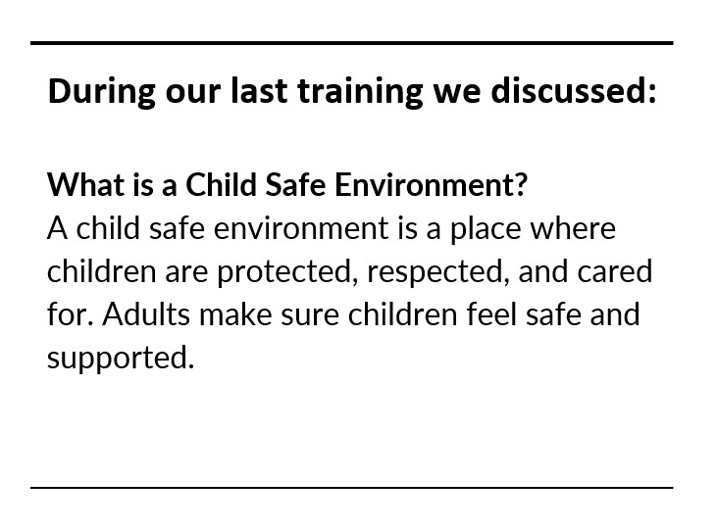
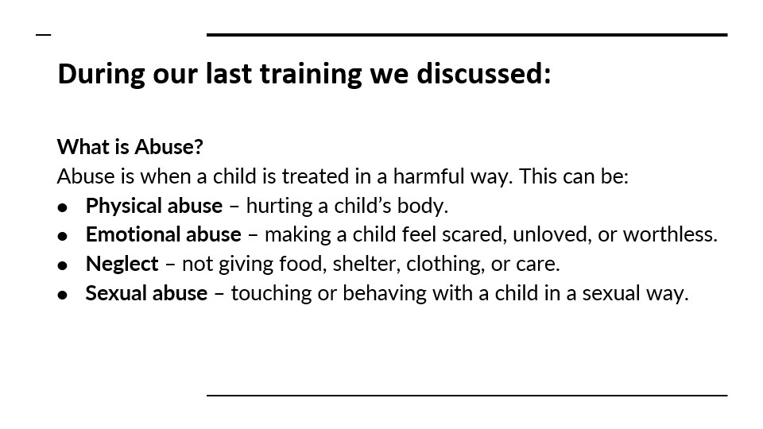

NOTES :
_______________________________________________________________________________________
_______________________________________________________________________________________
_______________________________________________________________________________________
_______________________________________________________________________________________
_______________________________________________________________________________________
_______________________________________________________________________________________
_______________________________________________________________________________________
_______________________________________________________________________________________
_______________________________________________________________________________________
_______________________________________________________________________________________
_______________________________________________________________________________________
_______________________________________________________________________________________
_______________________________________________________________________________________
_______________________________________________________________________________________
_______________________________________________________________________________________
_______________________________________________________________________________________
_______________________________________________________________________________________
_______________________________________________________________________________________

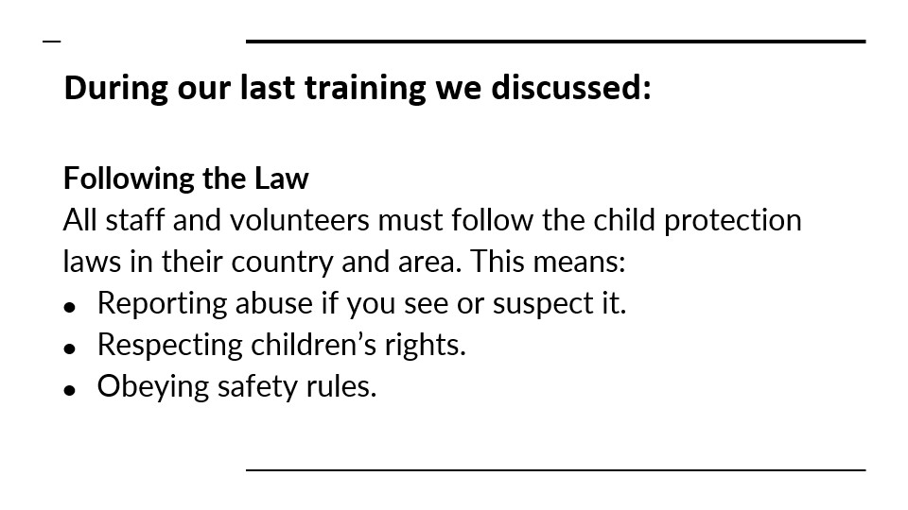
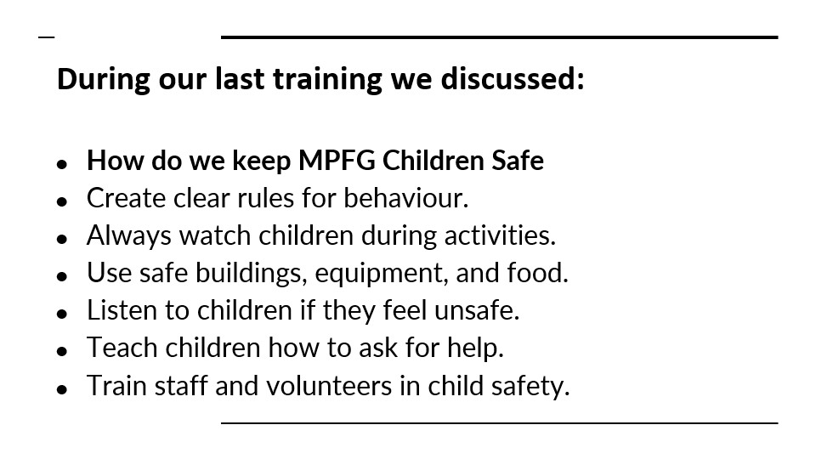

NOTES :
_______________________________________________________________________________________
_______________________________________________________________________________________
_______________________________________________________________________________________
_______________________________________________________________________________________
_______________________________________________________________________________________
_______________________________________________________________________________________
_______________________________________________________________________________________
_______________________________________________________________________________________
_______________________________________________________________________________________
_______________________________________________________________________________________
_______________________________________________________________________________________
_______________________________________________________________________________________
_______________________________________________________________________________________
_______________________________________________________________________________________
_______________________________________________________________________________________
_______________________________________________________________________________________
_______________________________________________________________________________________
_______________________________________________________________________________________

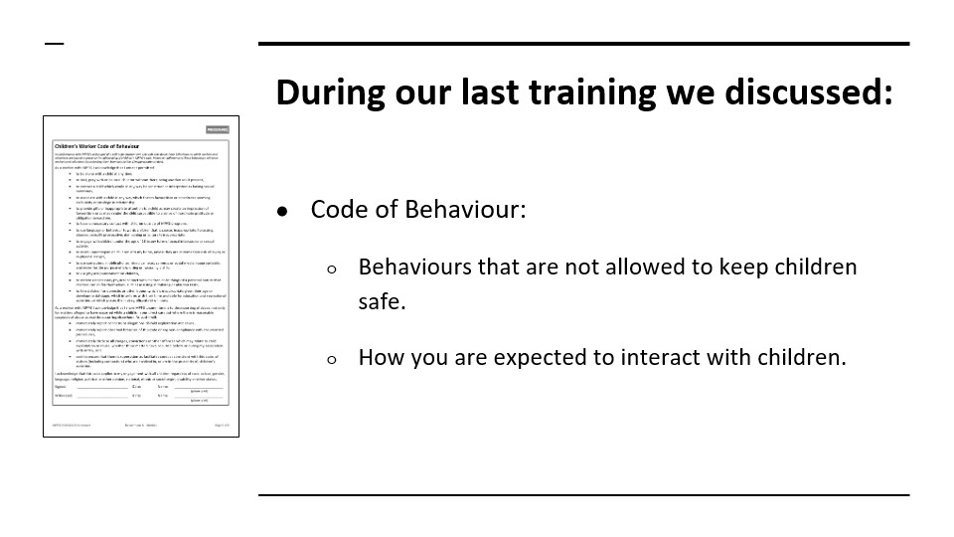
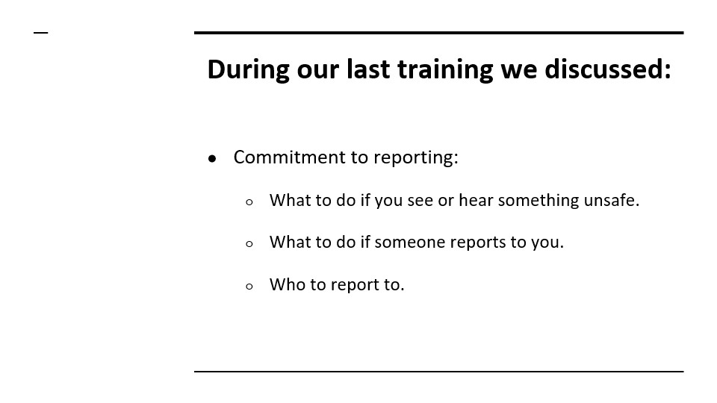

NOTES :
_______________________________________________________________________________________
_______________________________________________________________________________________
_______________________________________________________________________________________
_______________________________________________________________________________________
_______________________________________________________________________________________
_______________________________________________________________________________________
_______________________________________________________________________________________
_______________________________________________________________________________________
_______________________________________________________________________________________
_______________________________________________________________________________________
_______________________________________________________________________________________
_______________________________________________________________________________________
_______________________________________________________________________________________
_______________________________________________________________________________________
_______________________________________________________________________________________
_______________________________________________________________________________________
_______________________________________________________________________________________
_______________________________________________________________________________________

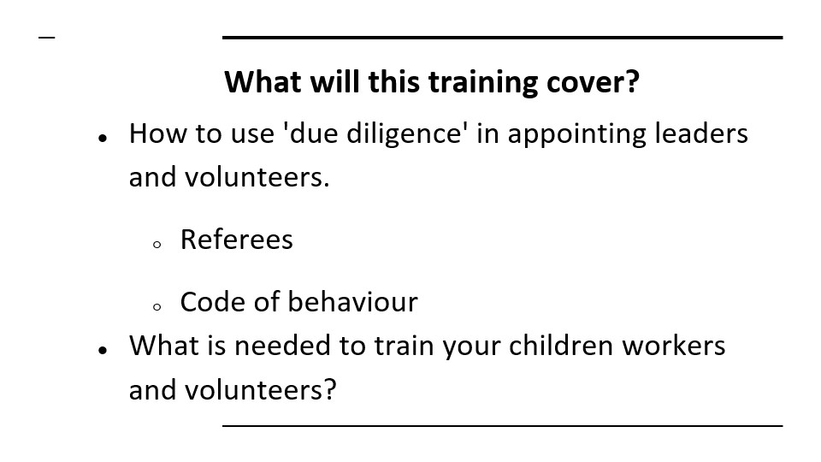
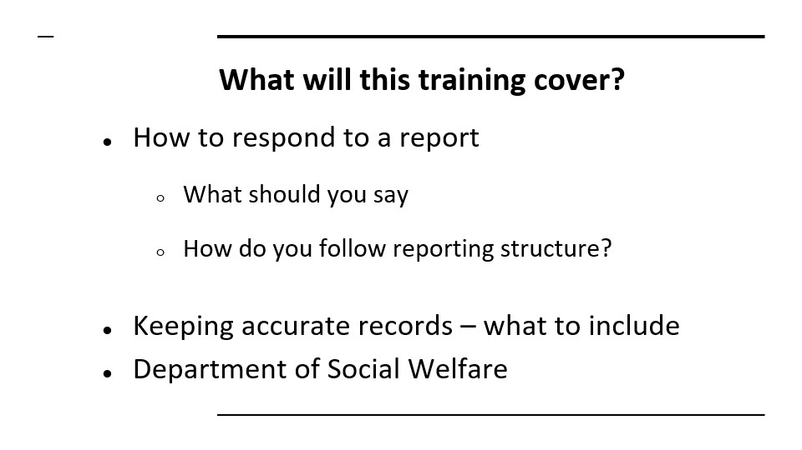

NOTES :
_______________________________________________________________________________________
_______________________________________________________________________________________
_______________________________________________________________________________________
_______________________________________________________________________________________
_______________________________________________________________________________________
_______________________________________________________________________________________
_______________________________________________________________________________________
_______________________________________________________________________________________
_______________________________________________________________________________________
_______________________________________________________________________________________
_______________________________________________________________________________________
_______________________________________________________________________________________
_______________________________________________________________________________________
_______________________________________________________________________________________
_______________________________________________________________________________________
_______________________________________________________________________________________
_______________________________________________________________________________________
_______________________________________________________________________________________

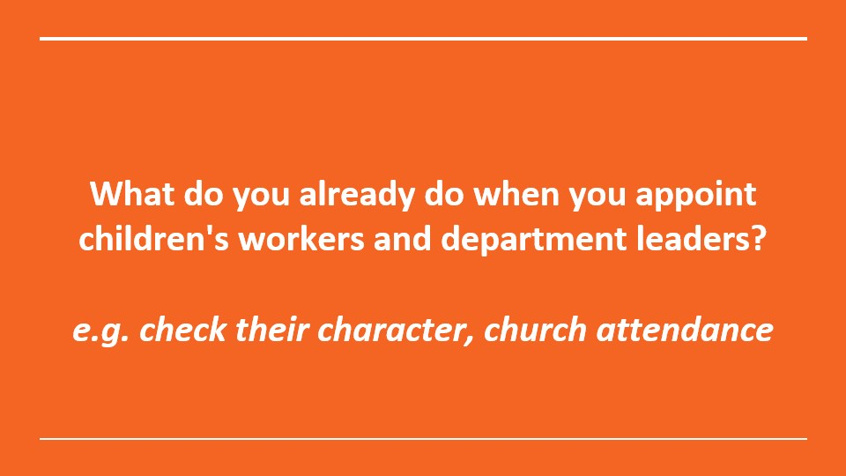
Group discussion: what is done now when appointing children's workers or volunteers?
e.g. do you check their character, church attendance?

NOTES :
_______________________________________________________________________________________
_______________________________________________________________________________________
_______________________________________________________________________________________
_______________________________________________________________________________________
_______________________________________________________________________________________
_______________________________________________________________________________________
_______________________________________________________________________________________
_______________________________________________________________________________________
_______________________________________________________________________________________
_______________________________________________________________________________________
_______________________________________________________________________________________
_______________________________________________________________________________________
_______________________________________________________________________________________
_______________________________________________________________________________________
_______________________________________________________________________________________
_______________________________________________________________________________________
_______________________________________________________________________________________
_______________________________________________________________________________________
_______________________________________________________________________________________
_______________________________________________________________________________________
_______________________________________________________________________________________
_______________________________________________________________________________________
_______________________________________________________________________________________
_______________________________________________________________________________________
_______________________________________________________________________________________
_______________________________________________________________________________________

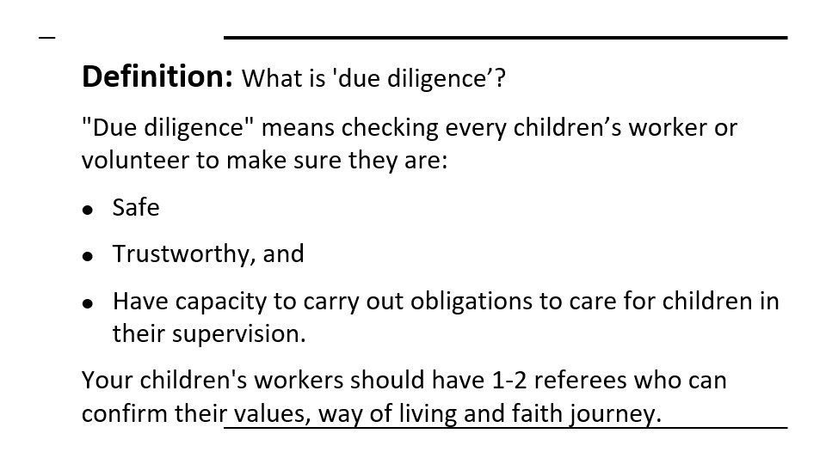
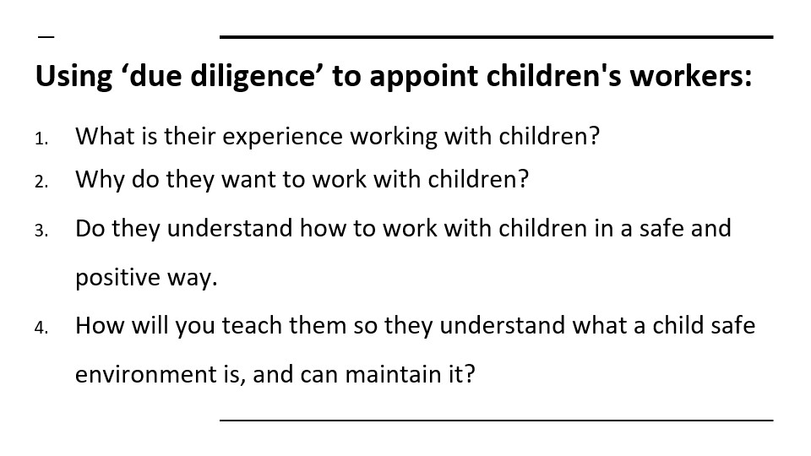

NOTES :
_______________________________________________________________________________________
_______________________________________________________________________________________
_______________________________________________________________________________________
_______________________________________________________________________________________
_______________________________________________________________________________________
_______________________________________________________________________________________
_______________________________________________________________________________________
_______________________________________________________________________________________
_______________________________________________________________________________________
_______________________________________________________________________________________
_______________________________________________________________________________________
_______________________________________________________________________________________
_______________________________________________________________________________________
_______________________________________________________________________________________
_______________________________________________________________________________________
_______________________________________________________________________________________
_______________________________________________________________________________________
_______________________________________________________________________________________

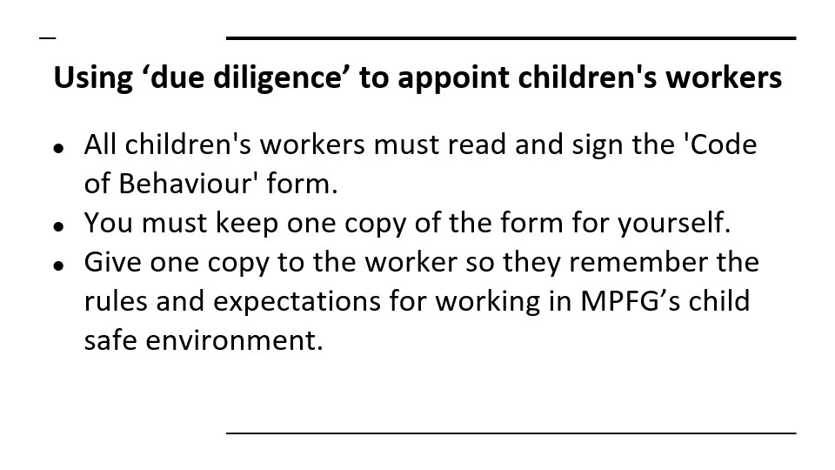
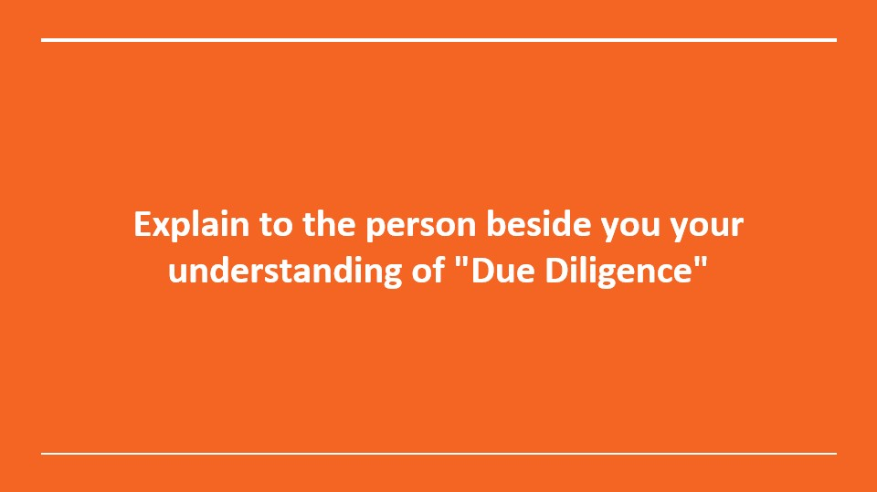
Group Discussion
NOTES :
_______________________________________________________________________________________
_______________________________________________________________________________________
_______________________________________________________________________________________
_______________________________________________________________________________________
_______________________________________________________________________________________
_______________________________________________________________________________________
_______________________________________________________________________________________
_______________________________________________________________________________________
_______________________________________________________________________________________
_______________________________________________________________________________________
_______________________________________________________________________________________
_______________________________________________________________________________________
_______________________________________________________________________________________
_______________________________________________________________________________________
_______________________________________________________________________________________
_______________________________________________________________________________________
_______________________________________________________________________________________
_______________________________________________________________________________________

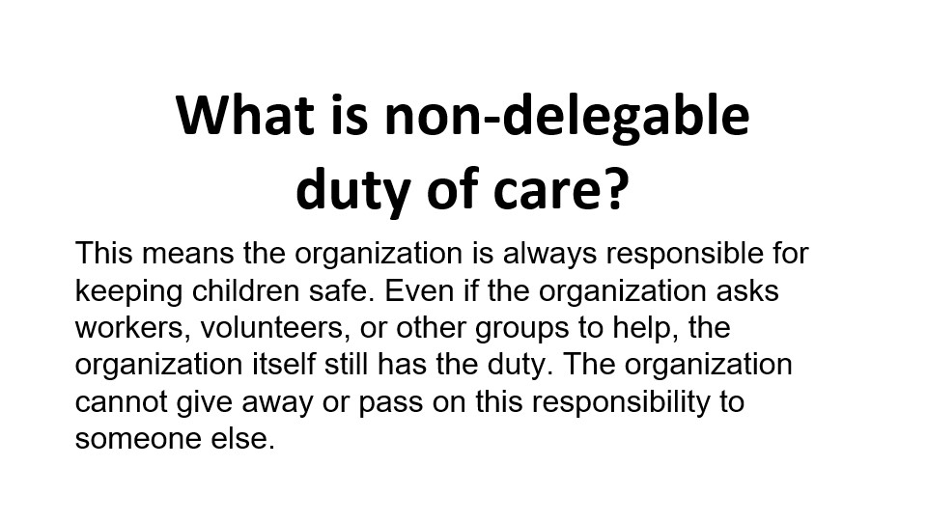
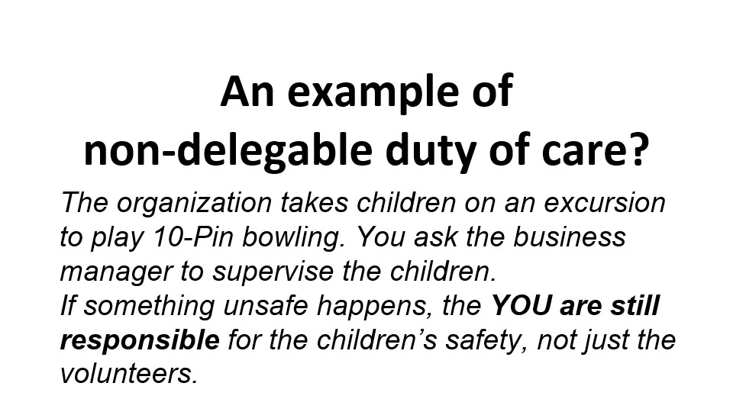

NOTES :
_______________________________________________________________________________________
_______________________________________________________________________________________
_______________________________________________________________________________________
_______________________________________________________________________________________
_______________________________________________________________________________________
_______________________________________________________________________________________
_______________________________________________________________________________________
_______________________________________________________________________________________
_______________________________________________________________________________________
_______________________________________________________________________________________
_______________________________________________________________________________________
_______________________________________________________________________________________
_______________________________________________________________________________________
_______________________________________________________________________________________
_______________________________________________________________________________________
_______________________________________________________________________________________
_______________________________________________________________________________________
_______________________________________________________________________________________

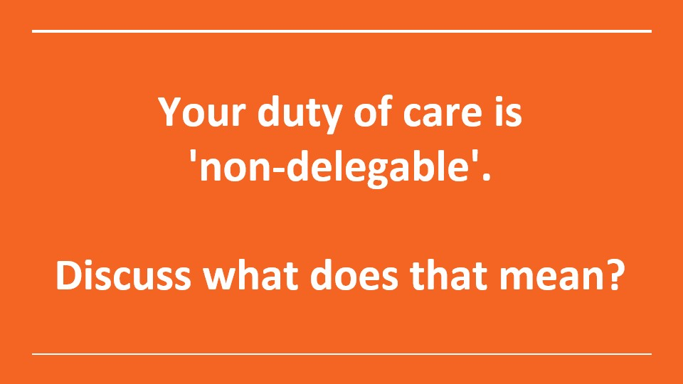

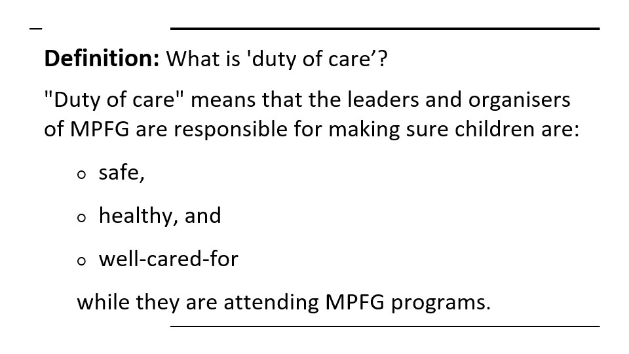

NOTES :
_______________________________________________________________________________________
_______________________________________________________________________________________
_______________________________________________________________________________________
_______________________________________________________________________________________
_______________________________________________________________________________________
_______________________________________________________________________________________
_______________________________________________________________________________________
_______________________________________________________________________________________
_______________________________________________________________________________________
_______________________________________________________________________________________
_______________________________________________________________________________________
_______________________________________________________________________________________
_______________________________________________________________________________________
_______________________________________________________________________________________
_______________________________________________________________________________________
_______________________________________________________________________________________
_______________________________________________________________________________________
_______________________________________________________________________________________

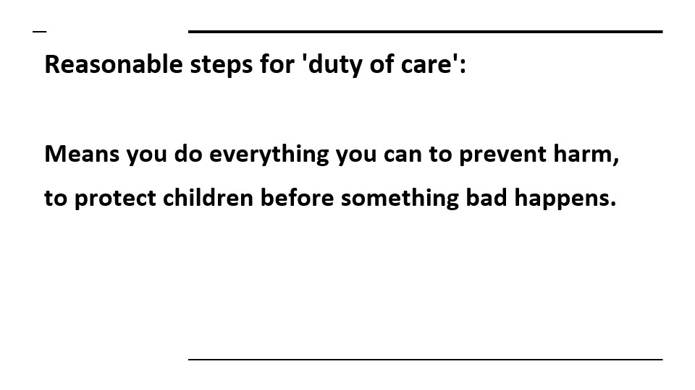
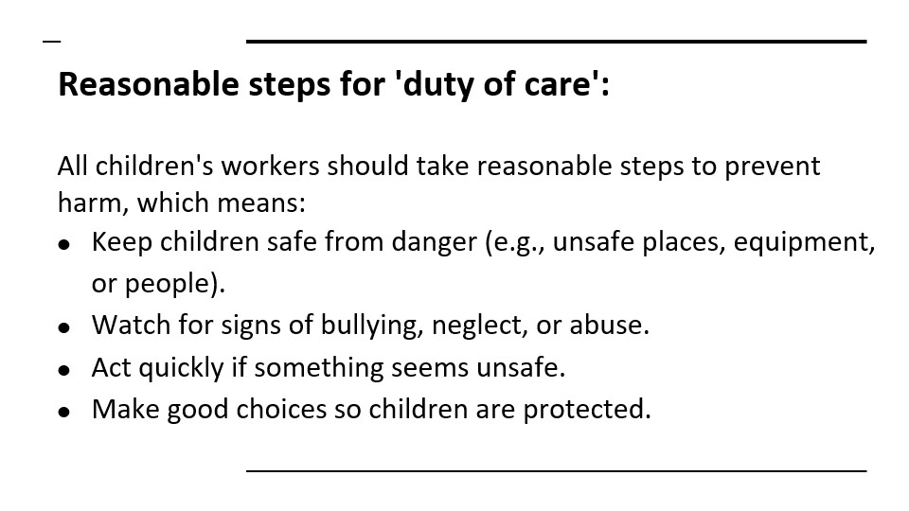

NOTES :
_______________________________________________________________________________________
_______________________________________________________________________________________
_______________________________________________________________________________________
_______________________________________________________________________________________
_______________________________________________________________________________________
_______________________________________________________________________________________
_______________________________________________________________________________________
_______________________________________________________________________________________
_______________________________________________________________________________________
_______________________________________________________________________________________
_______________________________________________________________________________________
_______________________________________________________________________________________
_______________________________________________________________________________________
_______________________________________________________________________________________
_______________________________________________________________________________________
_______________________________________________________________________________________
_______________________________________________________________________________________
_______________________________________________________________________________________

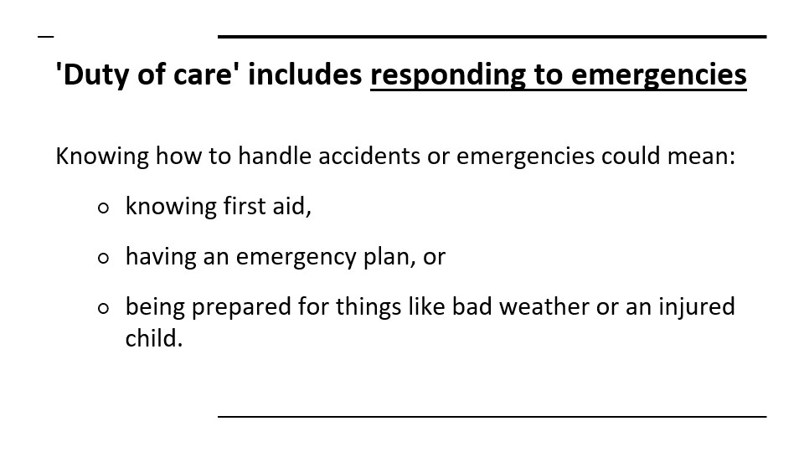
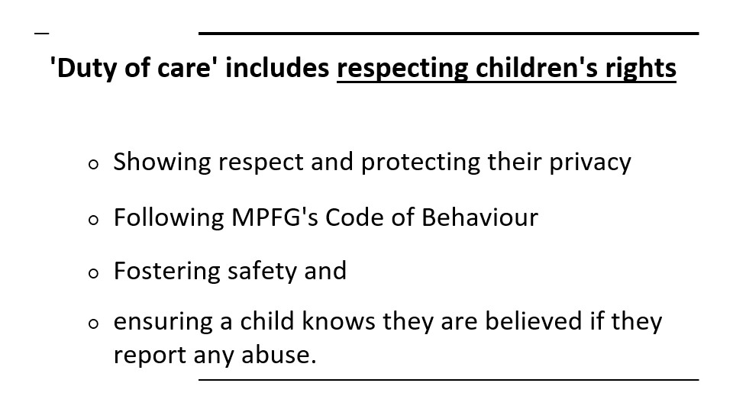

NOTES :
_______________________________________________________________________________________
_______________________________________________________________________________________
_______________________________________________________________________________________
_______________________________________________________________________________________
_______________________________________________________________________________________
_______________________________________________________________________________________
_______________________________________________________________________________________
_______________________________________________________________________________________
_______________________________________________________________________________________
_______________________________________________________________________________________
_______________________________________________________________________________________
_______________________________________________________________________________________
_______________________________________________________________________________________
_______________________________________________________________________________________
_______________________________________________________________________________________
_______________________________________________________________________________________
_______________________________________________________________________________________
_______________________________________________________________________________________

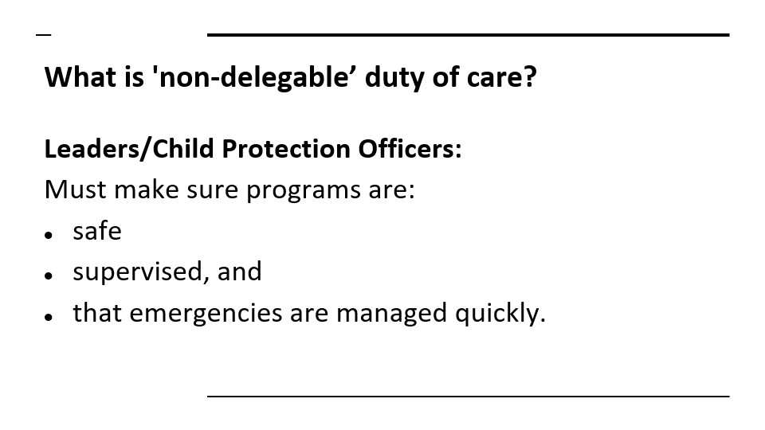
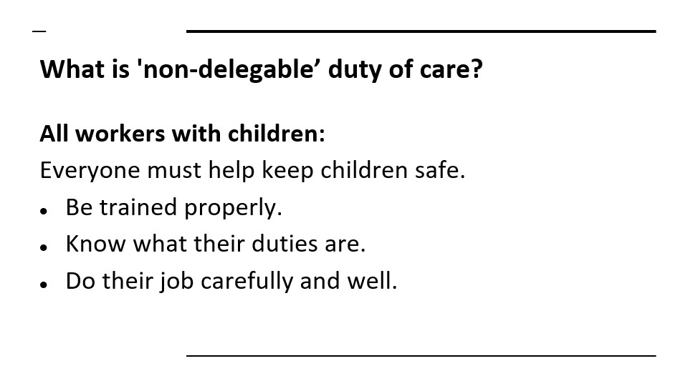

NOTES :
_______________________________________________________________________________________
_______________________________________________________________________________________
_______________________________________________________________________________________
_______________________________________________________________________________________
_______________________________________________________________________________________
_______________________________________________________________________________________
_______________________________________________________________________________________
_______________________________________________________________________________________
_______________________________________________________________________________________
_______________________________________________________________________________________
_______________________________________________________________________________________
_______________________________________________________________________________________
_______________________________________________________________________________________
_______________________________________________________________________________________
_______________________________________________________________________________________
_______________________________________________________________________________________
_______________________________________________________________________________________
_______________________________________________________________________________________

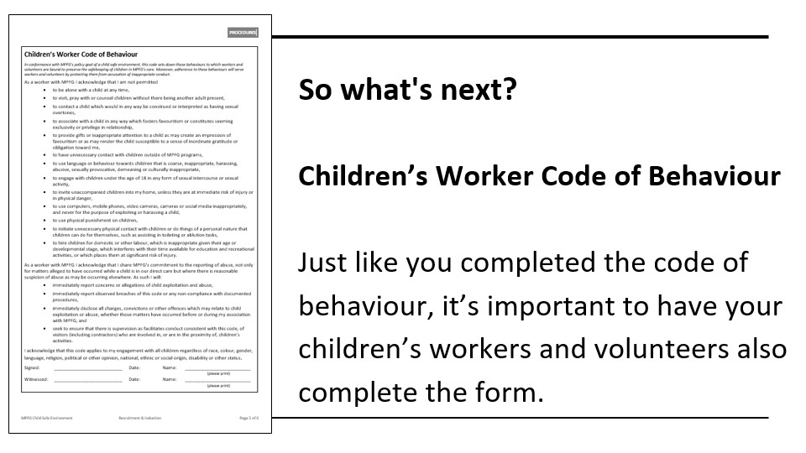


Group discussion: what do you think you will do if someone reports to you?

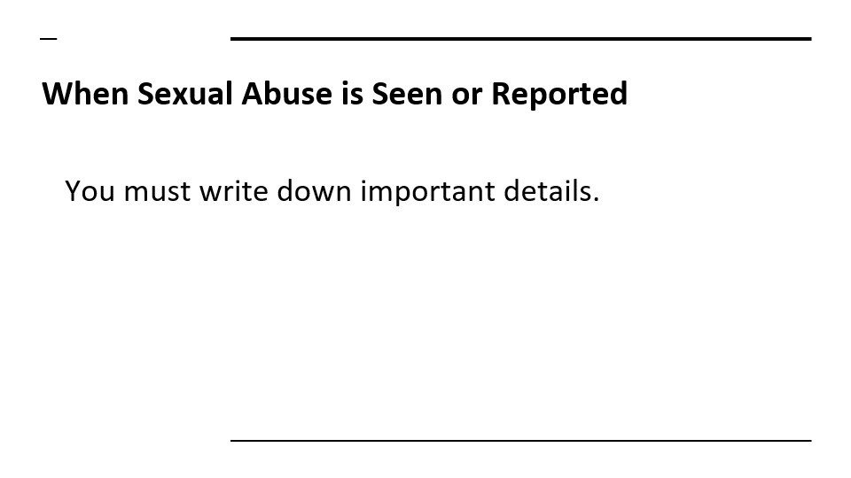
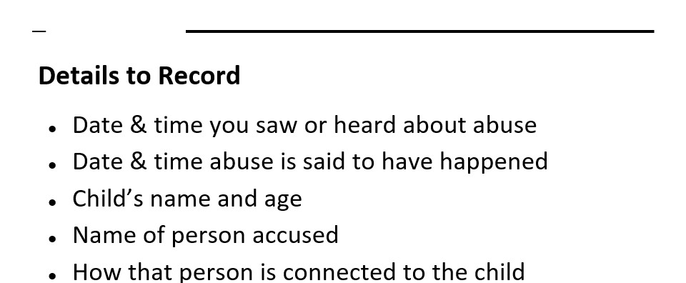
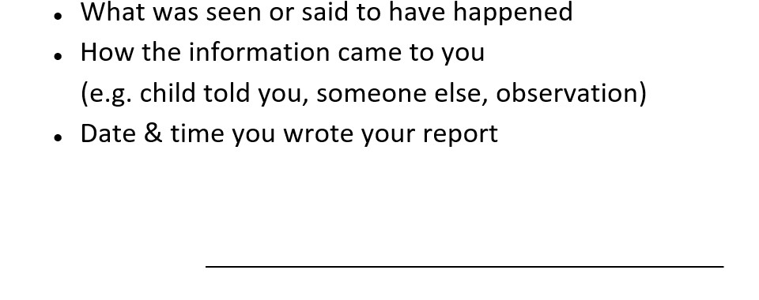
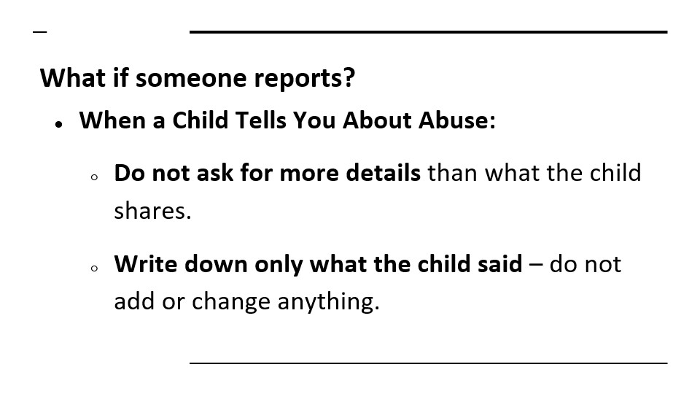
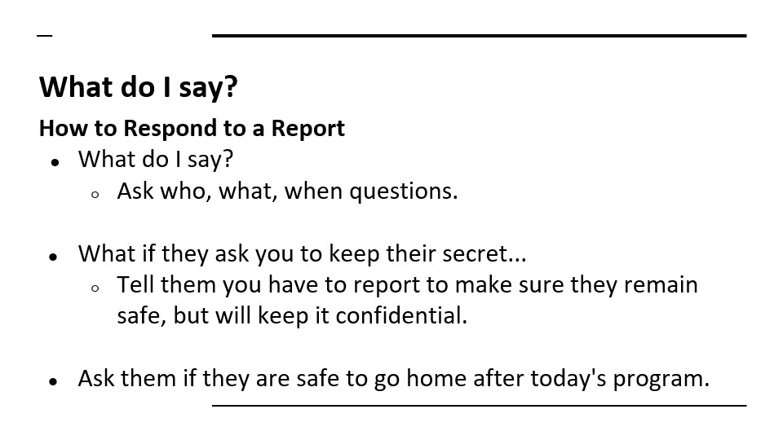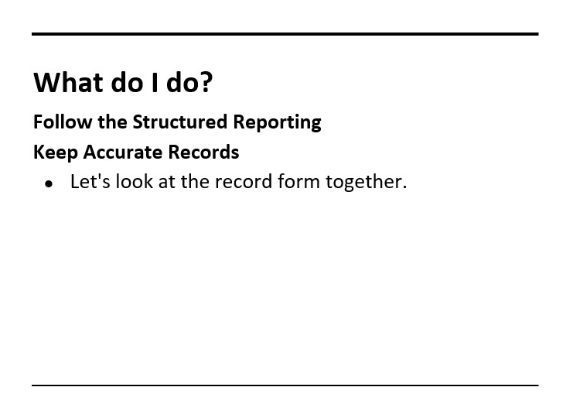

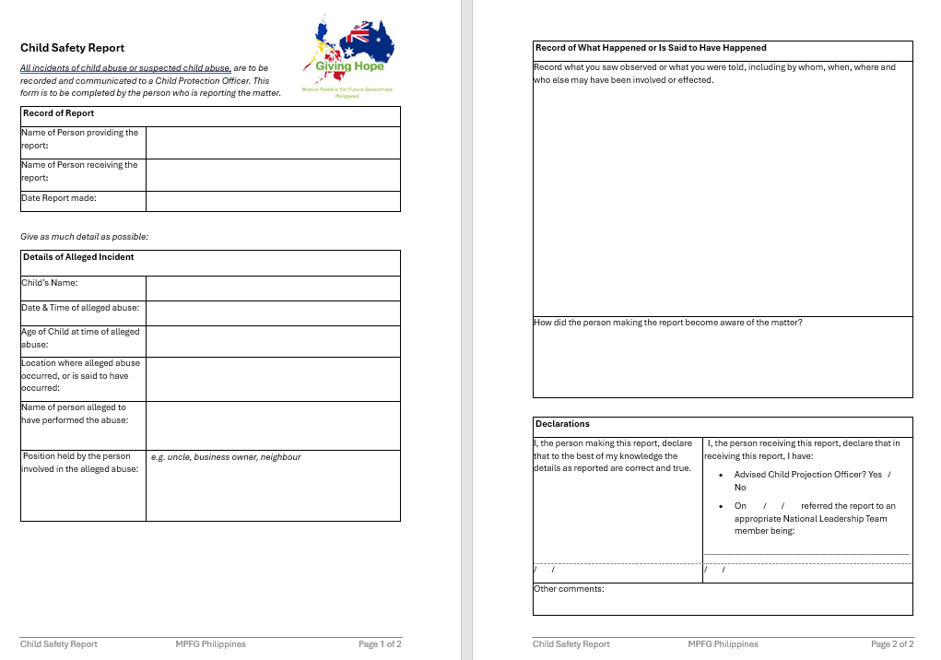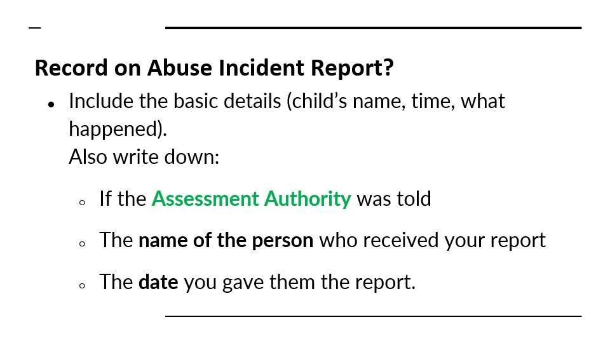

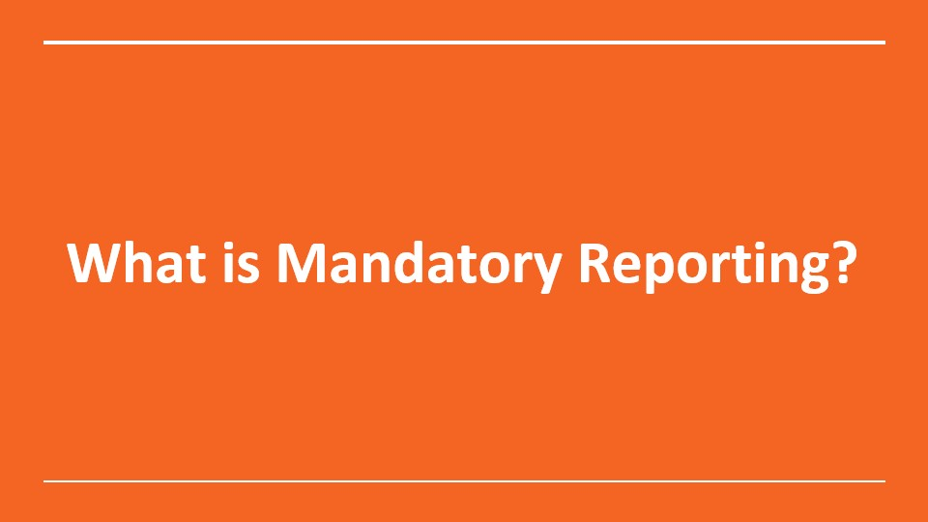
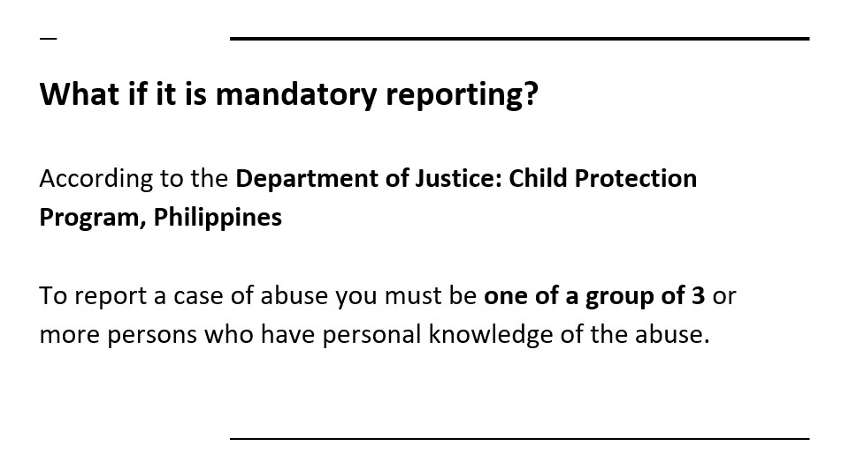

NOTES :
_______________________________________________________________________________________
_______________________________________________________________________________________
_______________________________________________________________________________________
_______________________________________________________________________________________
_______________________________________________________________________________________
_______________________________________________________________________________________
_______________________________________________________________________________________
_______________________________________________________________________________________
_______________________________________________________________________________________
_______________________________________________________________________________________
_______________________________________________________________________________________
_______________________________________________________________________________________
_______________________________________________________________________________________
_______________________________________________________________________________________
_______________________________________________________________________________________
_______________________________________________________________________________________
_______________________________________________________________________________________
_______________________________________________________________________________________

Let’s take a closer look at the appropriate structure for reporting:
Children’s Workers: Should only speak only to the Department Leader.
Department Leaders: Should only report only to regional coordinator/child protection officer.
Regional Coordinators & Child Protection Officers [CPO]: As a local church pastor or leader, you must report to the Assessment Authority or MPFG Philippines National Leader.

As the Regional Coordinator/CPO:
- it is YOUR responsibility whether you need to contact the Department of Social Welfare or your Local Barangay Council for the Protection of Children.
- Should you report to authorities, you must advise the Assessment Authority and keep them updated as you become aware of progress or action.
- You must maintain confidentiality to protect those involved and to protect the reputation of your local church, MPFG Philippines and Australia, as well as Bethesda Ministries International, Philippines.
- It is your responsibility to provide counselling to your volunteer children’s workers and department leaders in the event of them reporting to you, to ensure their wellbeing and closure of the matter.

NOTES :
_______________________________________________________________________________________
_______________________________________________________________________________________
_______________________________________________________________________________________
_______________________________________________________________________________________
_______________________________________________________________________________________
_______________________________________________________________________________________
_______________________________________________________________________________________
_______________________________________________________________________________________
_______________________________________________________________________________________
_______________________________________________________________________________________
_______________________________________________________________________________________
_______________________________________________________________________________________
_______________________________________________________________________________________
_______________________________________________________________________________________
_______________________________________________________________________________________
_______________________________________________________________________________________
_______________________________________________________________________________________
_______________________________________________________________________________________

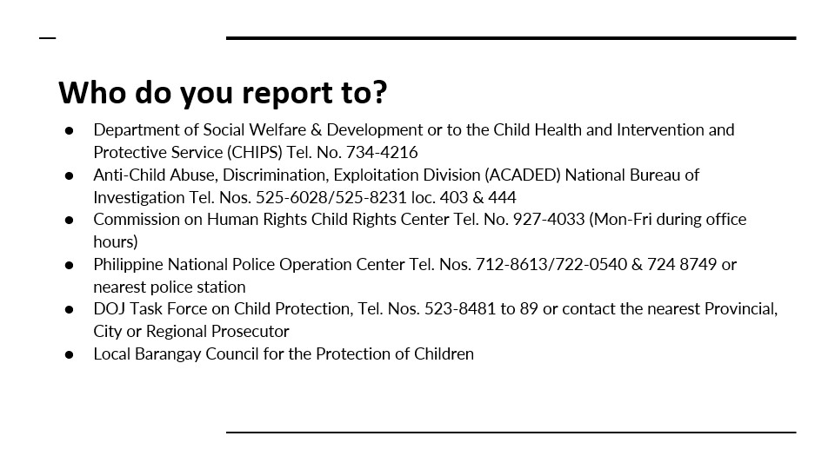

NOTES :
_______________________________________________________________________________________
_______________________________________________________________________________________
_______________________________________________________________________________________
_______________________________________________________________________________________
_______________________________________________________________________________________
_______________________________________________________________________________________
_______________________________________________________________________________________
_______________________________________________________________________________________
_______________________________________________________________________________________
_______________________________________________________________________________________
_______________________________________________________________________________________
_______________________________________________________________________________________
_______________________________________________________________________________________
_______________________________________________________________________________________
_______________________________________________________________________________________
_______________________________________________________________________________________
_______________________________________________________________________________________
_______________________________________________________________________________________

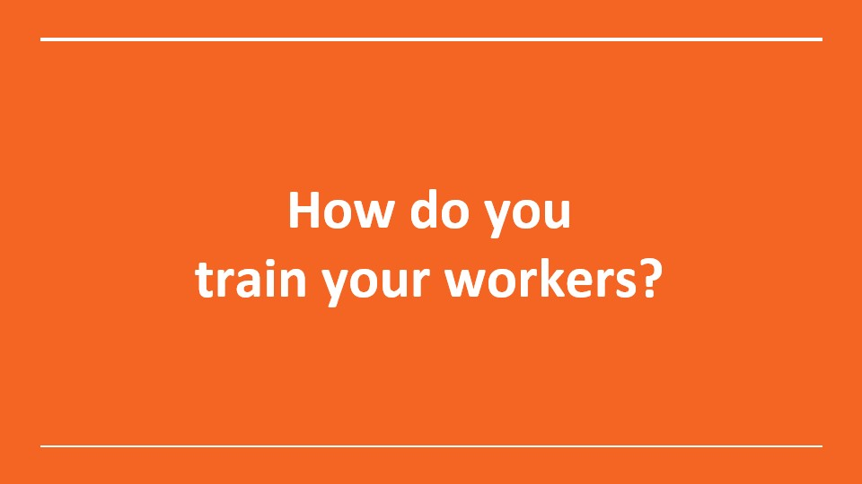

Essential Resources:
Visit our website to download resources to run your own training.

https://www.mpfg.org.au/child-safety-policy

Print copies of each document – one per person.

NOTES :
_______________________________________________________________________________________
_______________________________________________________________________________________
_______________________________________________________________________________________
_______________________________________________________________________________________
_______________________________________________________________________________________
_______________________________________________________________________________________
_______________________________________________________________________________________
_______________________________________________________________________________________
_______________________________________________________________________________________
_______________________________________________________________________________________
_______________________________________________________________________________________
_______________________________________________________________________________________
_______________________________________________________________________________________
_______________________________________________________________________________________
_______________________________________________________________________________________
_______________________________________________________________________________________
_______________________________________________________________________________________
_______________________________________________________________________________________

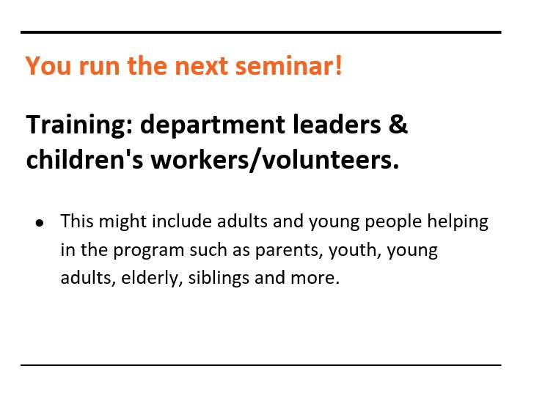
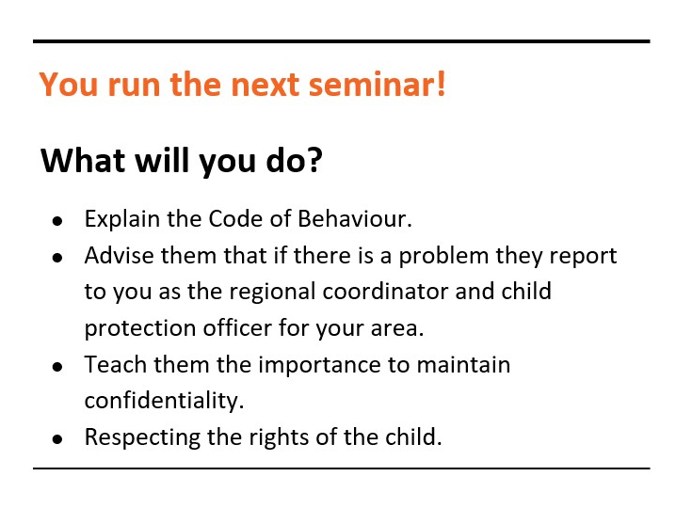
NOTES :
_______________________________________________________________________________________
_______________________________________________________________________________________
_______________________________________________________________________________________
_______________________________________________________________________________________
_______________________________________________________________________________________
_______________________________________________________________________________________
_______________________________________________________________________________________
_______________________________________________________________________________________
_______________________________________________________________________________________
_______________________________________________________________________________________
_______________________________________________________________________________________
_______________________________________________________________________________________
_______________________________________________________________________________________
_______________________________________________________________________________________
_______________________________________________________________________________________
_______________________________________________________________________________________
_______________________________________________________________________________________
_______________________________________________________________________________________

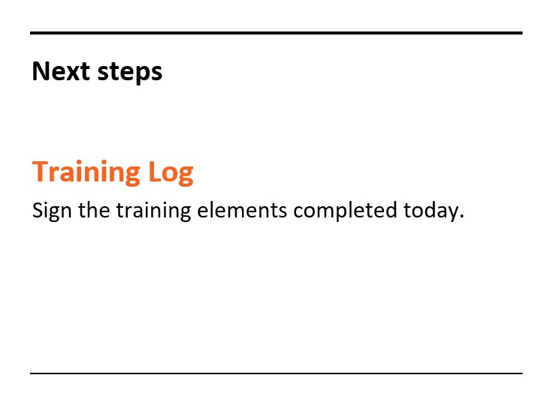
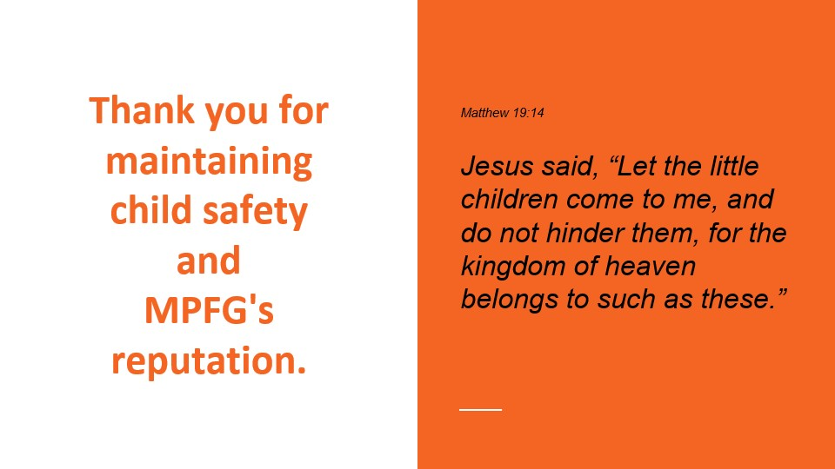

NOTES :
_______________________________________________________________________________________
_______________________________________________________________________________________
_______________________________________________________________________________________
_______________________________________________________________________________________
_______________________________________________________________________________________
_______________________________________________________________________________________
_______________________________________________________________________________________
_______________________________________________________________________________________
_______________________________________________________________________________________
_______________________________________________________________________________________
_______________________________________________________________________________________
_______________________________________________________________________________________
_______________________________________________________________________________________
_______________________________________________________________________________________
_______________________________________________________________________________________
_______________________________________________________________________________________
_______________________________________________________________________________________
_______________________________________________________________________________________

